Pipeline process

What the hell is a pipeline? A pipeline is a process of converting raw data (in this case a Maya file)into finished game art, its analogous to any manufacturing process that takes raw materials and creates a finished product. This document outlines the general steps in the SRR2 (Simpsons2) art pipeline and is not meant as a detailed how to guide.

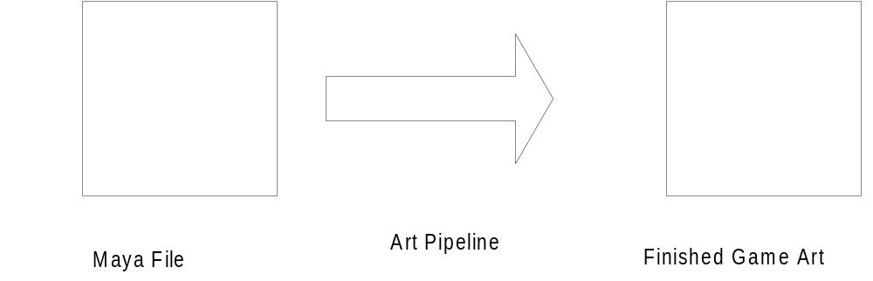

The Art Pipeline for Srr2 can be broken down to the these components

- The Maya File
- Pure3d Exporter
- Perforce
- Artchecker (Maintained by Chuck)
- ArtDatabase/ArtDB (Maintained by Chuck and Joel time permitting)
- Instancer Tool (Maintained by Cary)
- Pipeline commands (Maintained by Cary)

ART PIPELINE PROCESS

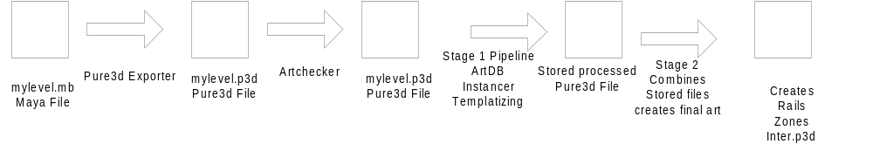

Workflow:

Typically an Artist will checkout the Maya file in Perforce. In Srr2 project the Maya files are stored in the ..Art\levels. Once the scene has been modified, the artist then should checkout the corresponding Pure3d file for the Scene. For Srr2 the Pure3d exported art, MUST be placed in the ..game\exportart\levels\.. The Artchecker should be run on the exported art to check for common errors, such as meshes exported without CVB (Color by Vertex) lighting info, textures greater than 8 bits per pixel, lambert shaders,etc. If the exported art has passed the Artchecker then it should be ok the pipe the art. Once the pipeline is finished, barring any errors, run the game and view the scene for correctness. If its ok then you can check in the export art Perforce under the game\exportart\levels.

Artchecker: Is a offline tool used to check for errors in the art that could cause the game to crash, it also tests the art against certain standards and reports the memory usage of level.

Usage: at a command prompt type

artchecker filename.p3d or artchecker filename.p3d all

With the all option the Artchecker will display the exact memory footprint of textures, animations, and meshes.

Currently it tests for these general cases
- textures greater than 8 bit color
- textures greater than 256 pixels width or height
- lambert shaders
- lit shaders
- meshes without CVB lighting info
- meshes greater than 500 tri’s
- meshes that reference lit shaders

In addition it also tests the art against the know art properties in the ArtDB if that object is entered into the ArtDB. For example if a l1_gen object has been added to the ArtDB as an object having 200 polys, then all objects named l1_gen are checked against the profile in the ArtDB.

Artdatabase: We keep a record of the art assets in our game in the Artdatabase. The records contain the names of the objects and certain art properties and physics properties. All records have unique names. We don’t need a record of every instance of an object in the game just the properties of objects of that type. For example if there were 80 light posts in a level we would have one record of a light post object named l1_lightpost. With a vertex count of 150 and poly count of 300. Also we can set the physics properties of an object inside the Artdatabase such as
- Sound to play when hit
- Particle effect when hit
- Animation to play when hit
- Friction of the object
- Mass of the object in KG’s
- Collision elasticity

Naming of Objects: In order for the various pipeline tools to work correctly we need to name objects and files correctly. Our object name convention inside MAYA is:

level/zone_objectname_

with all letters in lowercase. Generally the level prefix is enough, unless you want to differentiate the object even further, then add a zone or rail prefix. If the object is global and is used in multiple levels then use the prefix ‘g’.

These are examples of valid names

l1z3_gen_
l2_gen_
g_smalltree_
g_oaktree_
g_oaktreenight_
l1_oaktree_
l4_oaktree_
g_trashcanlid_
g_trashcanbase_
l3_landmark_
l5r5_burnsmansion_

These are NOT

z3_gens
L02_landmark_
Z3_genbrickhouse_
z3_gen_

For example you create a cube and you are going to eventually make a house out of it, and its going to be have the same properties as the other 30 generic houses found in the level then you would name the object

l2_gen_

If you check the Hypergraph and look under the object transform node at the mesh node it would be named l2_gen_Shape1 or something like that.

The name submitted to the ArtDB is l2_gen if the object hasn’t been submitted, then submit the name with a vertex count, poly count, and any physics properties of the object.

Instancer: This tools take a scene layout file and replaces the layout placeholders. In order for it to work correctly then naming is crucial. When the original object is exported the name of the exported Pure3D file must be the same as the mesh_name in the Hypergraph. The exported Pure file is then placed in the game\exportartlibrary folder. The name of the scenegraph, inside the layout file must also be named exactly the same as the Pure3d file its referencing.

For Example: You want to create a dumpster object that is going to get instanced for the seaside daytime level. So in Maya you create the object and name it l3_dumpster_ in the transform node. If you look at the mesh node for the object it will be called l3_dumpster_Shape, when you export it you MUST save the filename as l3_dumpster_shape.p3d. When you create the layout file for this instanced object you must name the scenegraph l3_dumpster_shape. For Clarity and to avoid problems use all lowercase, DO NOT mix cases

for example:

l1_patioChair_shape is NOT the same as l1_patiochair_shape. !!!

Pipeline commands:

To run the artpipeline for a command prompt, go to the game\build\art directory.

pipe levels: ‘the level you want to pipe’ ‘platform’ <clean>

For example:

to pipe the surburbs you would enter pipe levels:L01 PS2
to clean the L01 stored files pipe levels:L01 PS2 clean
to pipe all the levels leave the level info blank just type pipe levels: PS2

During the pipeline process the pipeline will store the intermediate files in the game\build\art\WORK\STORE folder. If you are iterating over the same scene and exporting the same pure3d file everytime you do not have to build the art clean, the pipeline should detect the newer exported art and just pipe the new stuff, however if the
changes aren’t showing up or old art is getting in the game then you can either delete the intermediate store files or build the art clean.

If there are errors during the pipeline process then the screen ouput will display an error saying that a certain file is missing, it may even continue, however there isn’t a message saying that the pipeline has FAILED.

